draft - playground > 2020-02-12 Lou

Limiting the sync date range
When first syncing the new device the amount of records to sync may be large (say around 50,000). This could take hours to sync, especially over a poor internet connection. For this reason it is possible for you to limit how many months of transactions and stocktakes you want to include.
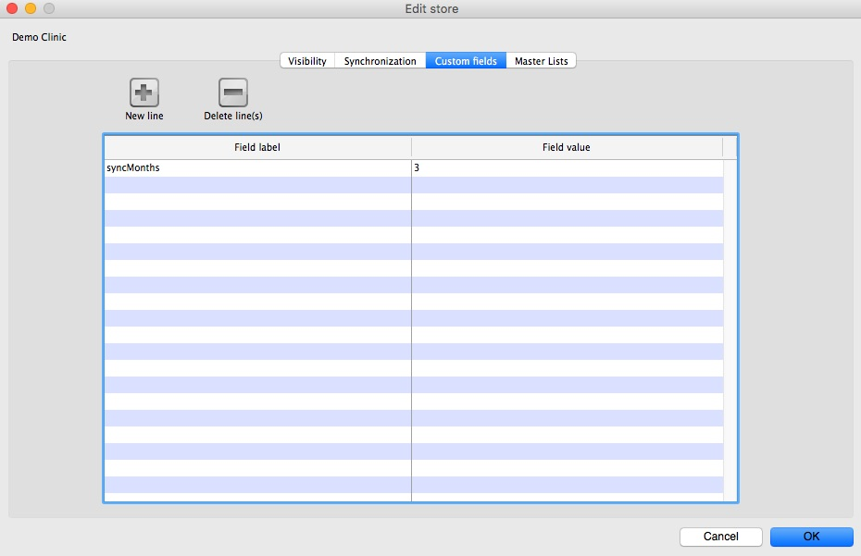
- Change the store Synchronisation type from collector to active or none to unlock editing custom fields
- Add a new line setting the Field label to syncMonths and the Field value to the number of months you wish to include
- To edit the custom field double-click on the line
- Change the store synchronisation type back to collector
Now whenever a sync is carried out the store will only sync transactions and stock takes for the previous X months.

