mSupply Table
This is a custom panel which will need to be installed on your server. Contact mSupply support if this panel is not available to you. The mSupply table is an extension of the bundled Table plugin, which adds * clickable actions to cells which update filter values * a button which allows exporting the data direct to excel (requires the msupply-dashboard-app plugin also )
Be aware that it also removes the Filter functionality of the bundled table plugin.
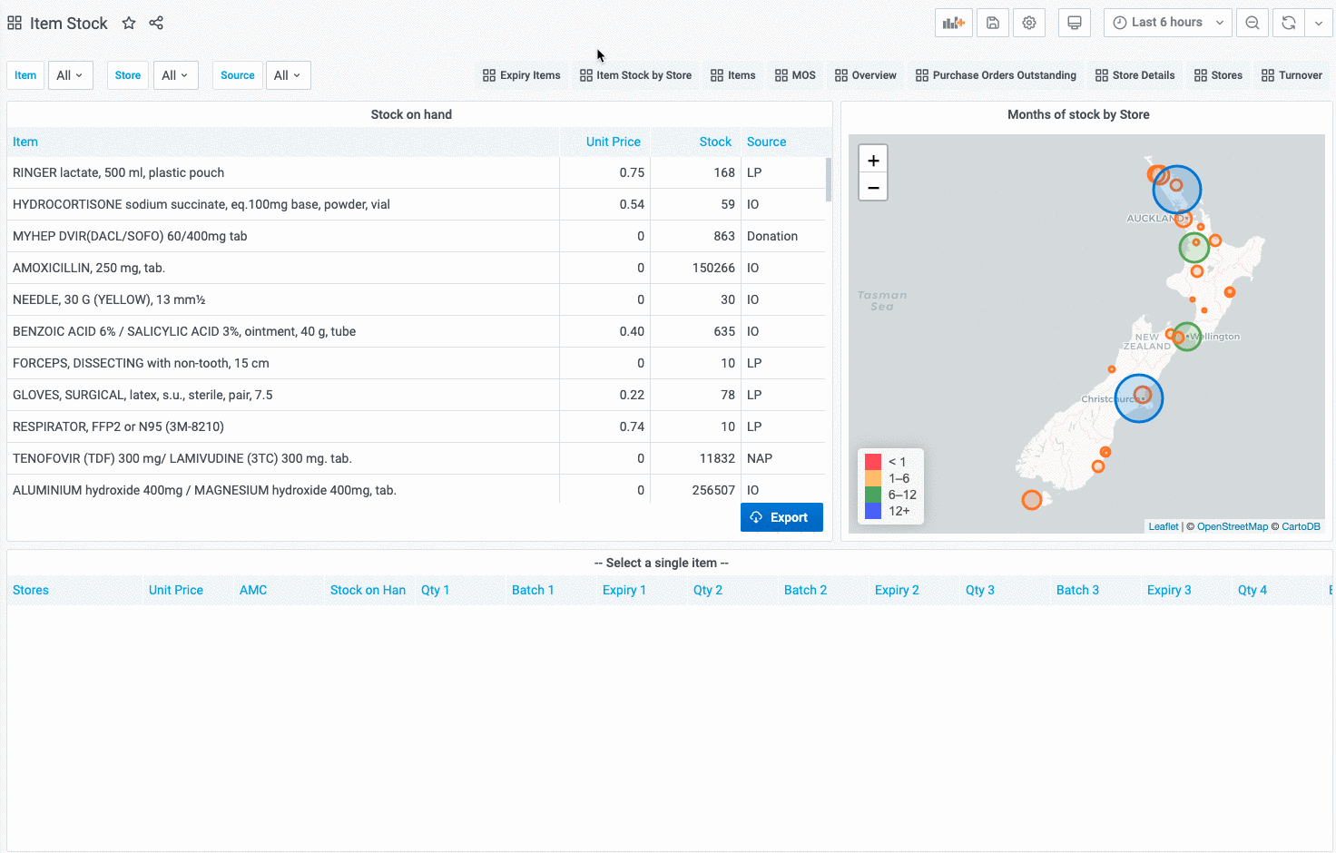
To use, select the msupply-table visualisation option:
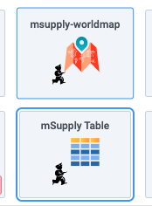
The new options available in the Display section are:
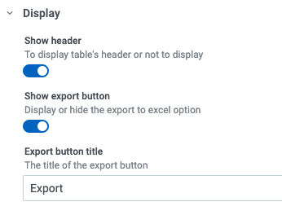
* Show export button toggles display of the export button * Export button title which allows customising of the export button text
And the option to link a cell to a variable is per field, so it can be specified as an override to select this for a single column only:


