Cette page n'est pas encore traduite entièrement. Merci de terminer la traduction
(supprimez ce paragraphe une fois la traduction terminée)

User Documentation

Online User Guides
Welcome to our collection of user documentation.
Click the links below to view the docs for our projects.
mSupply Mobile User Guide  mSupply Mobile User Guide | mSupply Dashboard: User Guide  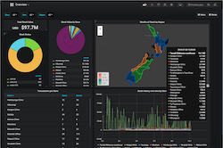mSupply Dashboard User Guide

Downloadable User Guides
Downloadable and printable versions of the user guides in PDF format are also available.
Note that the online guides are usually updated more frequently than the downloadable versions.
- Updated PDF Mobile user guide on its way

