Configurer le module vaccins

Paramètres du dépôt sur le serveur central
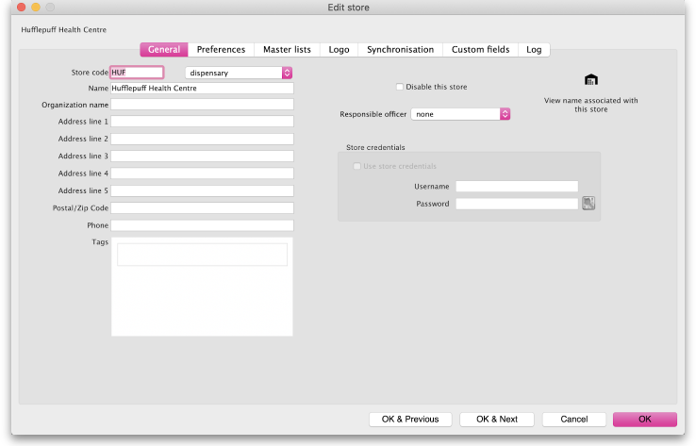
Assurez-vous que le dépôt a la visibilité sur au moins un article signalé comme vaccin.
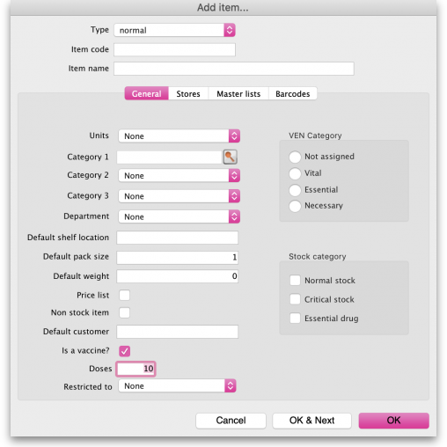
Si vous souhaitez renseigner quand un patient a refusé un vaccin, vous devez créer un évènement patient. Sinon, cette donnée ne sera pas sauvegardée.
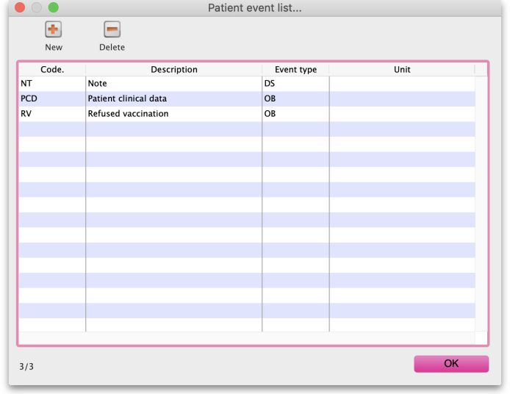
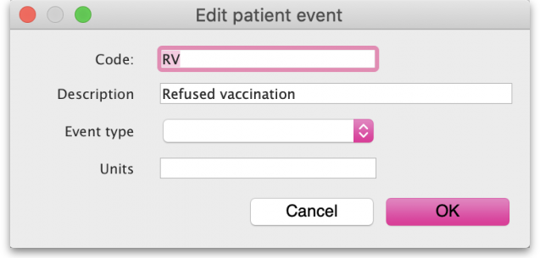
Si vous souhaitez renseigner des informations supplémentaires pendant la vaccination, prenez contact avec la Fondation mSupply. Nous n'avons pas d'interface pour que vous puissiez créer les formulaires vous-mêmes.
Une fois terminée, votre menu d'accueil mSupply Mobile ressemblera à ça:
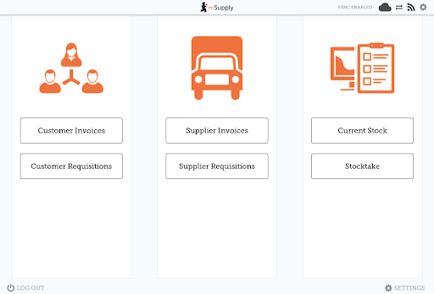
Connectez-vous et synchronisez manuellement une première fois. La fonction Vaccinations apparaitra alors sur le menu d'accueil:
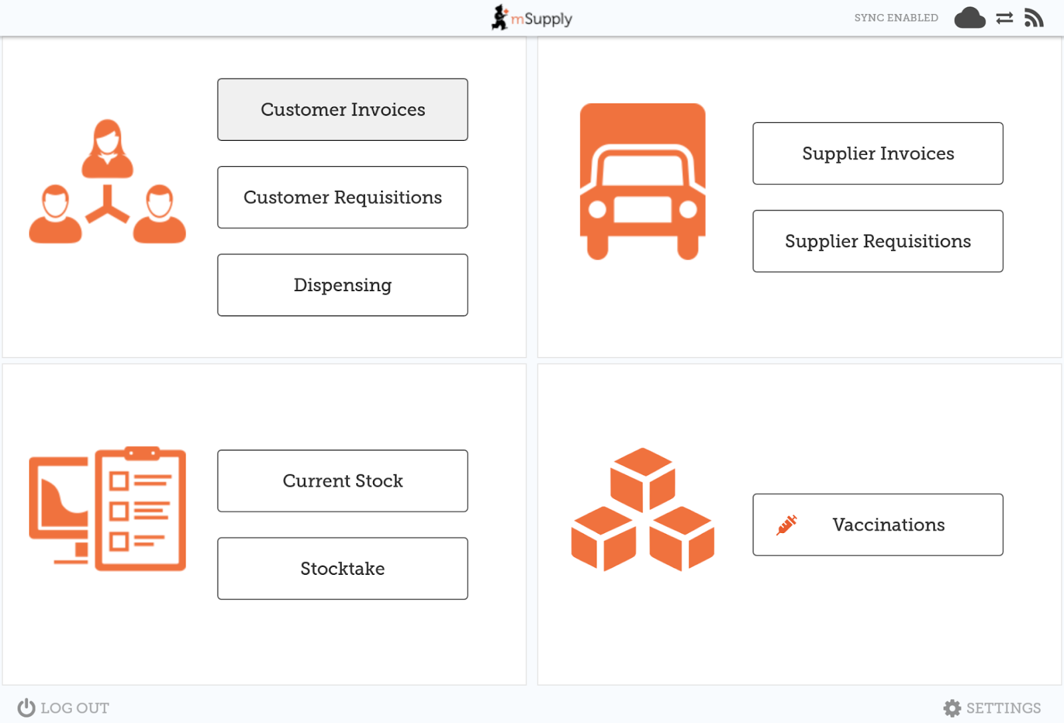

Configurer le formulaire d'information supplémentaire du patient
Nous utilisons le standard JSON-Schema pour définir à la fois les champs du formulaire qui seront visibles à l'écran and les contraintes sur ces champs.
Les contraintes sont les suivantes:
- si le champ est obligatoire ou non
- le type de valeur (ex: uniquement un nombre)
- valeur minimale et valeur maximale
- les valeurs par défaut
Once an agreed set of information has been defined, contact us to upload the form onto your server. In future versions of mSupply you will be able to do this process yourself.
Une fois qu'un ensemble de champs a été défini, contactez-nous pour uploader le formulaire sur votre serveur. Dans les versions futures de mSupply, vous serez en mesure de réaliser cela vous-mêmes.
Un exemple de JSON schema ci-dessous: Le schema et l'interface résultante de ce schema sont visibles ici

Exemple de Schema
{
"type": "object",
"title": "Extra information",
"properties": {
"respondentContactData": {
"title": "Respondent Contact Data",
"description": "Contact data of the respondent if the respondent is not the patient.",
"type": "object",
"properties": {
"firstName": {
"title": "First Name",
"description": "The first name of the respondent",
"type": "string",
"maxLength": 2,
"errorMessage": "Hey! that names way to long, buddy!"
},
"lastName": {
"title": "Last Name",
"description": "The last name of the respondent",
"type": "string",
"minLength": 50,
"errorMessage": "Hey! that names way to short, buddy!"
},
"relationshipToPatient": {
"title": "Relationship to patient",
"description": "The relationship between the respondent and patient",
"type": "string",
"enum": [
"Mother",
"Father",
"Sister",
"Brother",
"Aunty",
"Uncle",
"Grandmother",
"Grandfather",
"Friend/Neighbour",
"Other"
]
}
}
},
"patientClinicalData": {
"title": "Patient Clinical Data",
"description": "The patients clinical data",
"type": "object",
"properties": {
"comorbiditiesImmunocompromised": {
"title": "Comorbidities / Immunocompromised",
"description": "The patients comorbidities",
"type": "string",
"enum": [
"Diabetes",
"Hypertension",
"Asthma",
"Cancer (all types)",
"Cerebral Vascular Accident",
"Chronic Kidney Disease",
"Chronic Obstructive Airway Disease",
"Immunocompromised",
"Rheumatic Heart Disease",
"Ischemic Heart Disease",
"Other"
]
},
"previousSeriousAllergicReactions": {
"title": "Previous serious allergic reactions",
"description": "Has the patient had any serious allergic reactions in the past?",
"type": "boolean",
"default": false
},
"previousAdverseEventsFollowingImmunisation": {
"title": "Previous adverse events following immunisation",
"description": "Has the patient had any adverse effects following an immunisation in the past?",
"type": "boolean",
"default": false
},
"currentlyPregnant": {
"title": "Currently Pregnant",
"description": "Is the patient currently pregnant?",
"type": "boolean",
"default": false
},
"currentlyLactating": {
"title": "currentlyLactating",
"description": "Is the patient currently lactating?",
"type": "boolean",
"default": false
}
}
},
"Covid 19 Status": {
"type": "object",
"properties": {
"everTestedPositiveForCOVID19": {
"type": "boolean",
"default": false,
"description": "Has the patient ever tested positive for COVID-19'",
"title": "Ever tested positive for COVID-19"
},
"Date of diagnosis": {
"title": "Date of diagnosis",
"format": "date",
"type": "string"
}
}
},
"Covid 19 Vaccination Data": {
"type": "object",
"properties": {
"Covid-19 Vaccine Type": {
"type": "string",
"enum": [
"Astra-zeneca",
"Pfizer",
"Moderna",
"Johnson & Johnson"
],
"title": "COVID-19 Vaccine type",
"description": "The type of COVID-19 vaccine the patient is receiving",
"default": "Astra-zeneca"
},
"Date COVID-19 vaccine dose 1": {
"type": "string",
"format": "date",
"title": "Date COVID-19 vaccine dose 1",
"description": "The date of the patients first Covid-19 vaccine",
"errorMessage": "Error message"
},
"Date COVID-19 vaccine dose 2": {
"type": "string",
"format": "date",
"title": "Date COVID-19 vaccine dose 2",
"description": "The date of the patients second Covid-19 vaccine"
},
"Any AEFI experienced": {
"type": "boolean",
"default": false,
"title": "Any AEFI experienced",
"description": "Has the patient experienced any AEFI"
},
"Reporting form for AEFI if AEFI experienced": {
"type": "string",
"title": "Reporting form for AEFI if AEFI experienced",
"description": "I dunno what this is"
}
}
}
}
}

