Cette page n'est pas encore traduite entièrement. Merci de terminer la traduction
(supprimez ce paragraphe une fois la traduction terminée)

4. Configuring the Store

4.01. Making items visible to the new store using a Master List
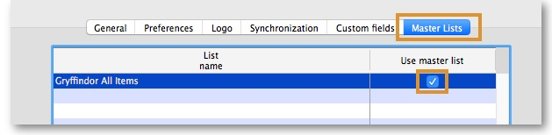
- Click on the Master Lists tab and select at least one Master List.
- Click OK
- Click OK again

4.02. Setting up correct synchronisation settings
If you have used store_create_from_name for creation of the store, and you have specified the sync site that the store will be Active on, then all you need to do here is:
- Change the Synchronisation type for this store on the Primary Server to Collector if so desired (normally the case)
- Configure this new store's Sync type to be Transfer or Active/Collector for any other sync sites that need to deal with this store.
- Edit store synchronisation settings (Special > Show Stores > Double-click on store > Synchronisation > Click to Unlock, enter code to edit):
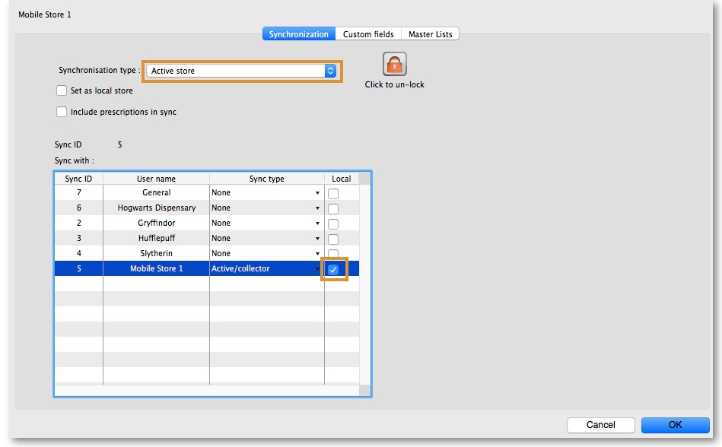
- In the table below, in row of the Sync site that was created for this store, tick the tickbox in the Local column. This will automatically change the Sync type for that site to Active/Collector.
- Set Synchronisation type at the top to Collector
- Click OK

4.03. Make Store visible to other Stores
- Edit the 'name' associated with the Store and configure visibility to other Stores appropriately

