Cette page n'est pas encore traduite entièrement. Merci de terminer la traduction
(supprimez ce paragraphe une fois la traduction terminée)

6. Reviewing the setup

6.01. Check the store is working via mSupply Desktop
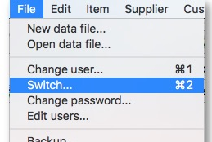
- On the Primary server, log in to the new Store.
If you are already logged in to mSupply Desktop you can switch to the new Store via the File menu > Switch
- Check that the correct Items/Master List(s) are visible

6.02. Start the web server
Remember: the syncing of the store only works when the web server is running!

