mSupply Mobile User Guide menu

5. Supplier Requisitions (Program Orders)
You would like to order some stock from your supplier (General Warehouse) for a program.
You could create a General Order, adding items one by one, but this could take a long time and items may be missed.
Instead, you can create a Program Order, which will automatically populate your requisition with items in the program.

1. Click on Supplier Requisitions
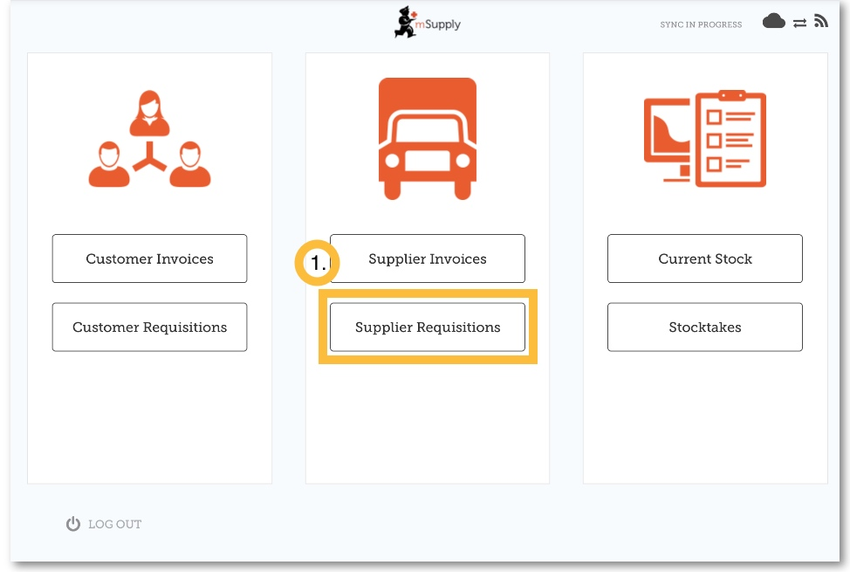

2. Click on Program Order
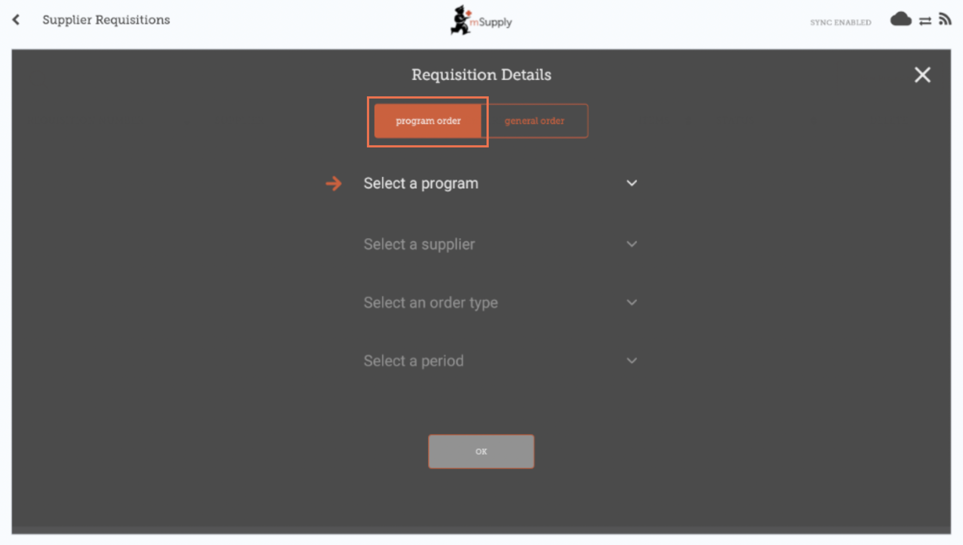

3. Select the Program, Supplier, Order Type and Period
This information must be completed sequentially. The arrow points to which step you are up to, and the tick shows which steps have been completed.
When selecting the Order Type, further details can be seen on the right:
- Maximum MOS: maximum number of months' stock to be kept for each item, which will help determine the suggested quantities to order
- Threshold MOS: items with number of months' stock less than this value will appear in the order by default
- Maximum orders per period: maximum number of orders that can be placed in a given period
When selecting the Period, further details can be seen on the right:
- Period dates i.e. the interval of the period
- Number of requisitions created so far for the same period, supplier and order type

4. Click OK and review the requisition
The requisition is created and is populated with all program items. Note that you cannot add additional items to a Program Requisition.
Why are there are no items visible in this example?
- The Hide Over Stocked button is selected by default, which hides all items that have stock over the threshold MOS.
- All the stock on hand in this example is over the threshold MOS, so no items are visible.
- When you click the Show Over Stocked button, all items that are over the threshold MOS appear.
Note that the Price displayed in a Program Requisition is the price the supplier sells the item for.

5. You can click on Use Suggested Quantities...
If you are certain that you are not ordering an item which you have not previously ordered! By choosing this option, mSupply will automatically calculate the amounts of each item you require, once it builds up a history of how much stock you're using.
Alternatively, enter the Requested Quantity for individual items.

6. Click the View Regimen Data button
If regimen data is necessary for the requisition, enter values and comments then close the screen.

7. When you are completely sure that everything is correct...

Click the Finalise button, then Confirm and your order will go to the supply store.
Even if you don't have internet at the time, it's ok! The order will send automatically when you do have internet later.

