mSupply Mobile User Guide menu

Supplier Requisitions
If you would like to order some stock from your supplier, tap on Supplier Requisitions.
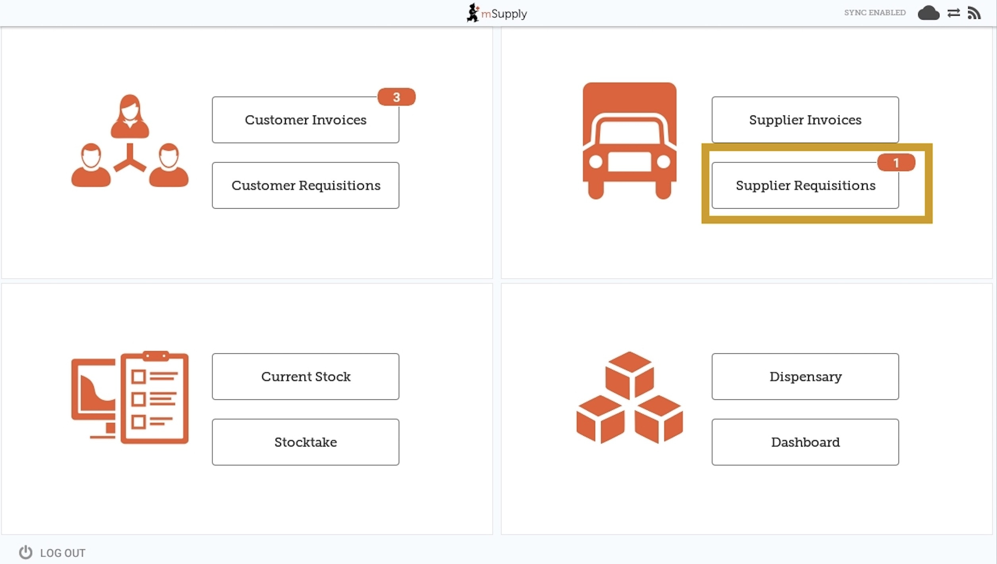
The Supplier Requisition window will display Current requisitions by default.
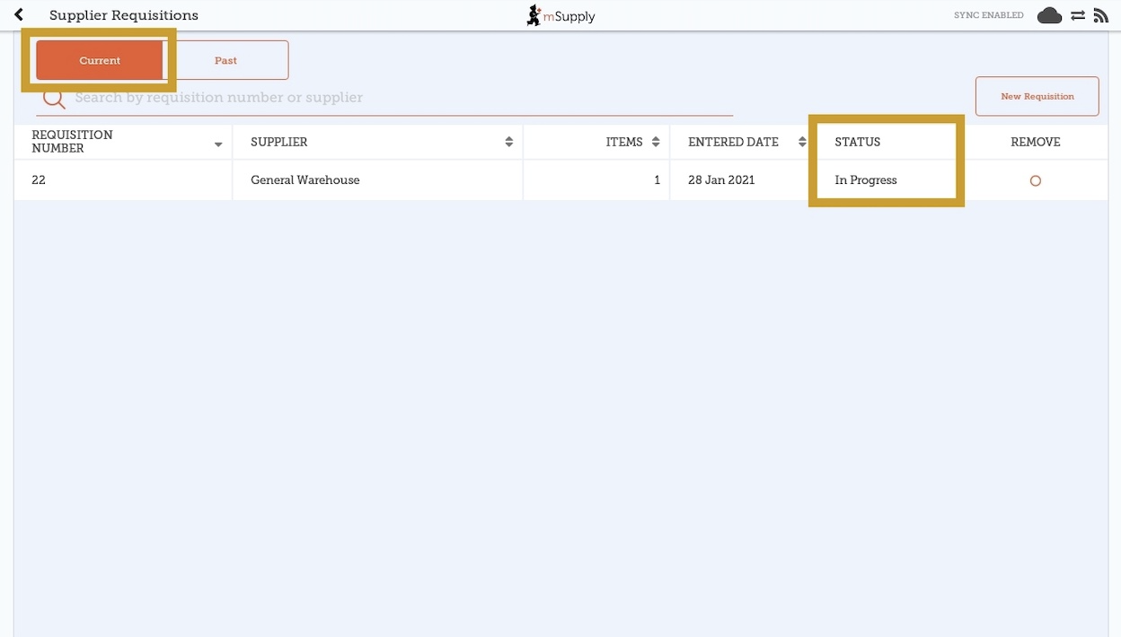
These are the requisitions that are In Progress (in the Status column). You can tap on any unfinalised requisition to open and continue work.
To view completed supplier requisitions, tap the Past tab.
The orange badge above Supplier Requisitions on the home page tells you if there are any unfinalised supplier requisitions - in the screenshots above, you can see that there is one unfinalised supplier requisition.
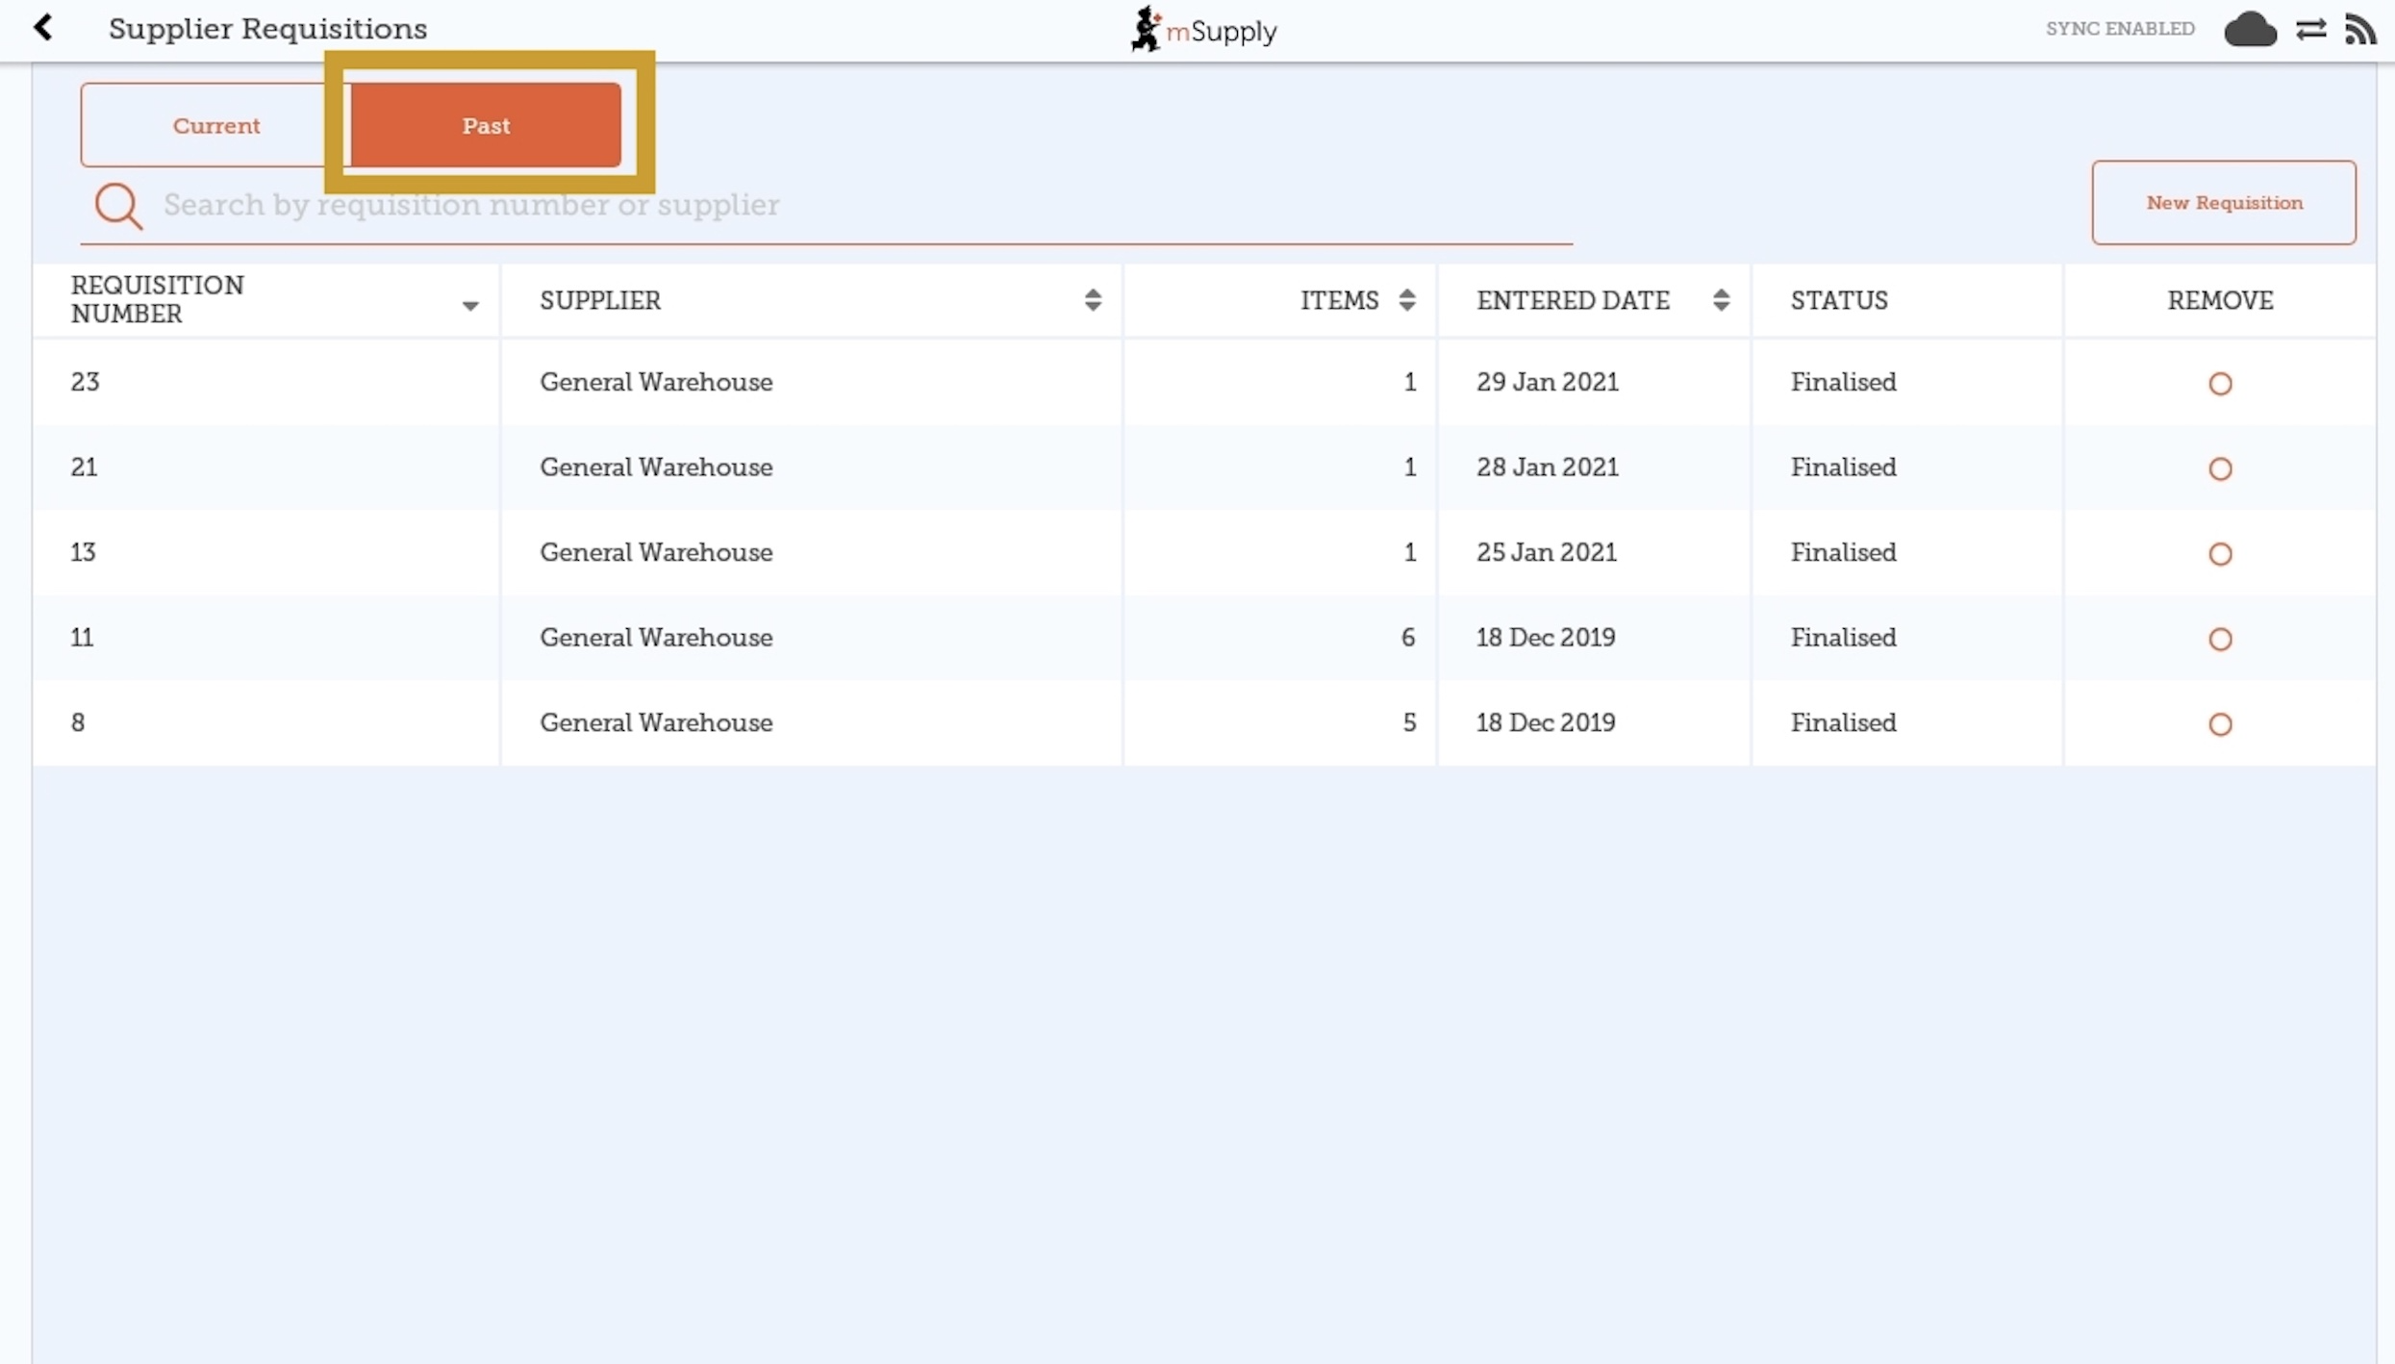
The list of past requisitions will all have a Status of Finalised. You can tap on any row to view a finalised requisition. However, no further changes can be made to finalised requisitions.

New Supplier Requisition
If you wish to create a new requisition, tap on New Requisition.
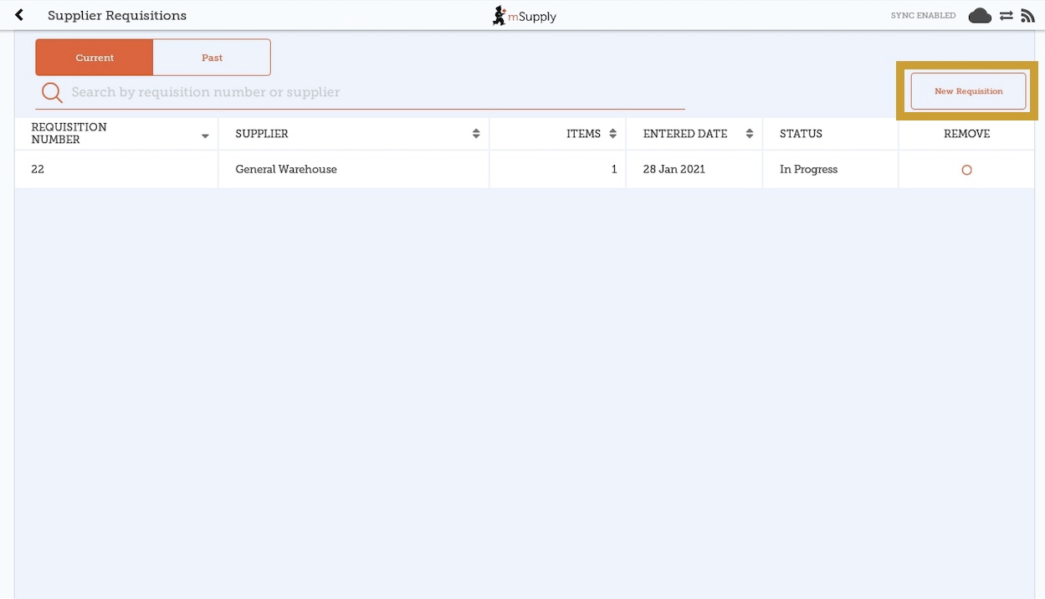

Adding items to a Supplier Requisition

Small Orders
If you only have a few items, tap New Item. This is the best option for small orders.
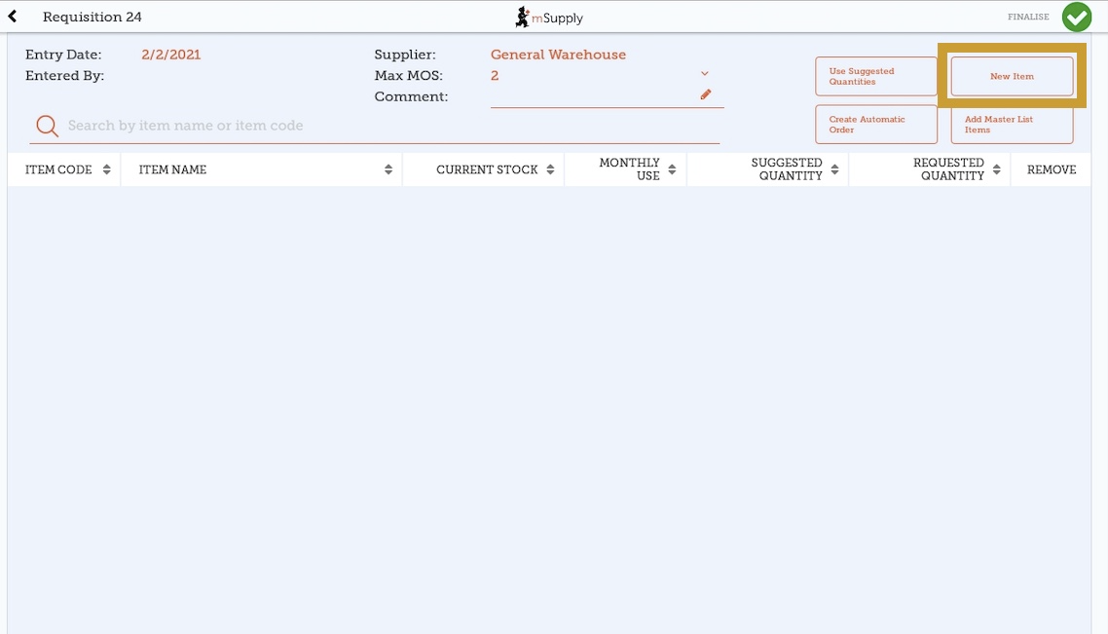

Start typing to search for the item.
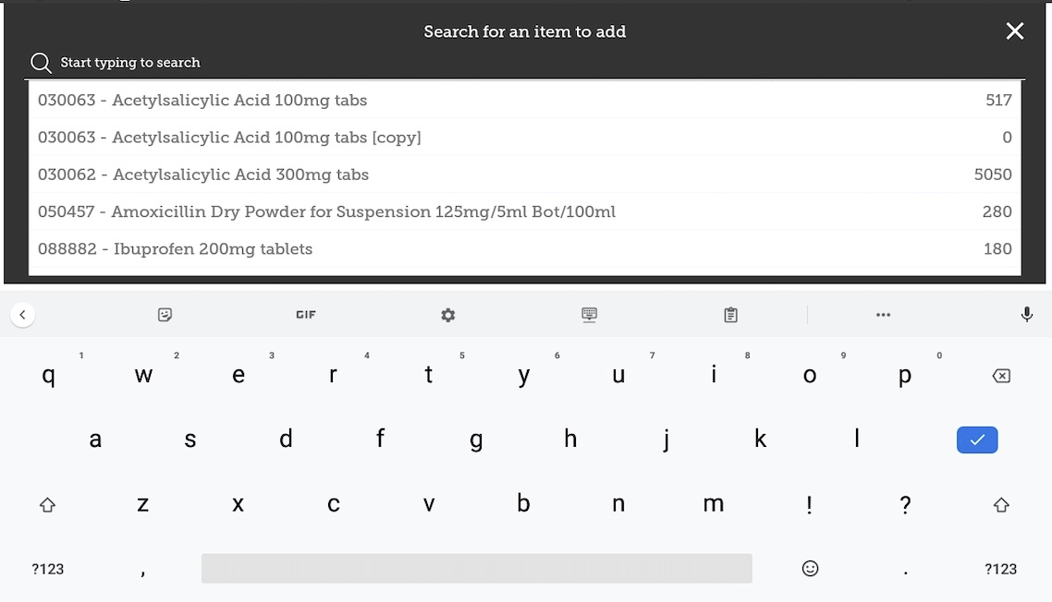
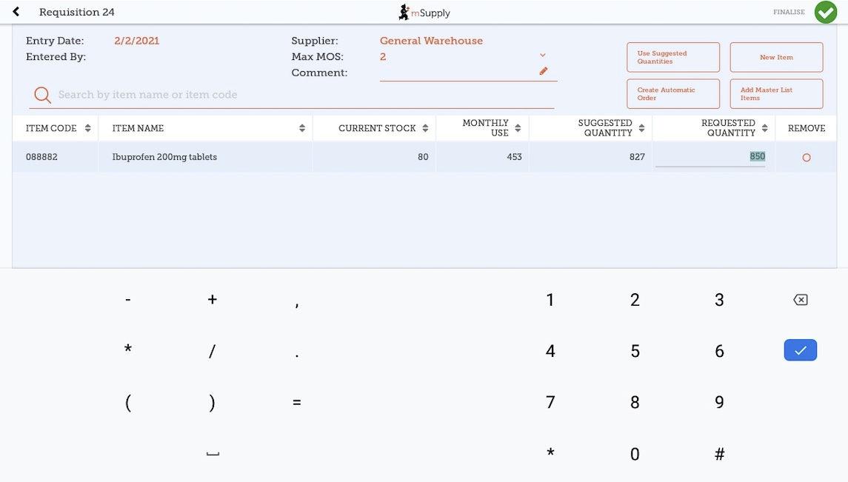
In this case, we need to purchase Ibuprofen 200mg tablets so we select this item.
When you select an item, it will be added to the requisition. The following information is provided about the item:
- Item Code and Item Name: as per your mSupply item list details
- Current Stock: how much stock currently available in your facility
- Monthly Use: how much stock your facility uses each month on average (based on the last three months).
- Suggested Quantity: how much stock mSupply Mobile suggests that you order based on your monthly use and the maximum months of supply you wish to order for your facility.
mSupply Mobile has a tool that helps you determine the quantity of stock to order. Select the number of months of supply that you wish to order using the MaxMOS dropdown box in the header. If you select a larger MaxMOS, the suggested quantity of stock to order will be larger. Suggested quantity is calculated as (Monthly Use x MaxMOS) - Current Stock. So for the above example for Ibuprofen 200mg tablets, (453*2)-80=827
- Requested Quantity: this is set to zero by default. You can either change manually by tapping in the cell and changing the number.

Larger Orders
If you have a lot of items to order (for example, when you are placing your main order), it can be slow to add them one by one.
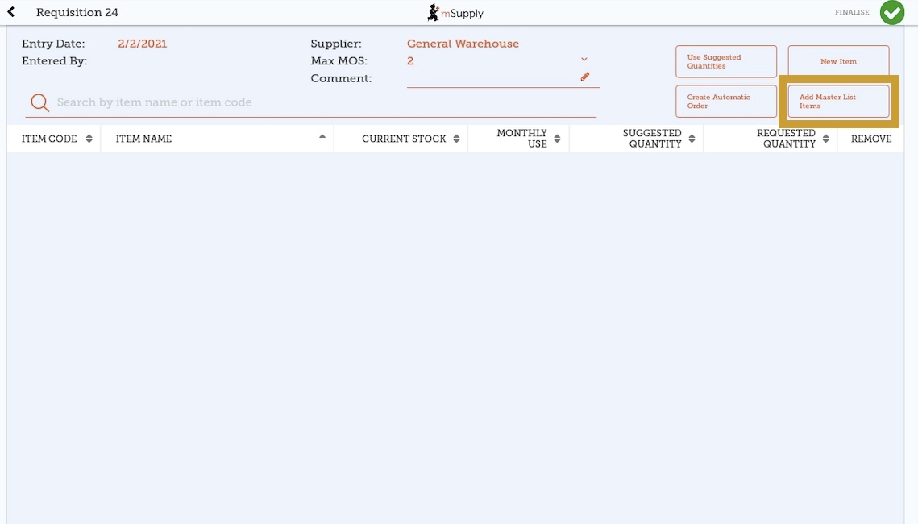
To add a lot of items at once, tap Add Master List Items.
Select one or more master lists by tapping on the check box next to the master list (the row will turn orange once selected). Only master lists visible to your store are shown. In this example, there is only one master list available. Once you have made your selection, tap Done.
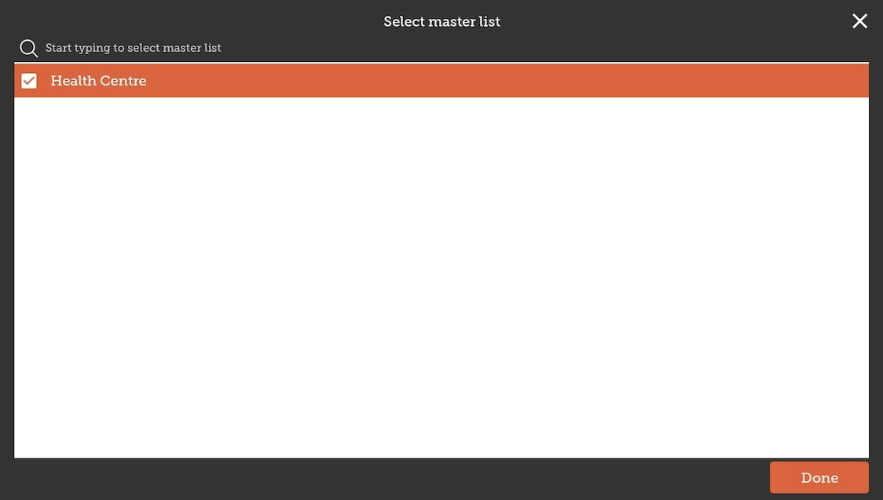
The items on the selected master list(s) will then automatically appear in the supplier requisition.
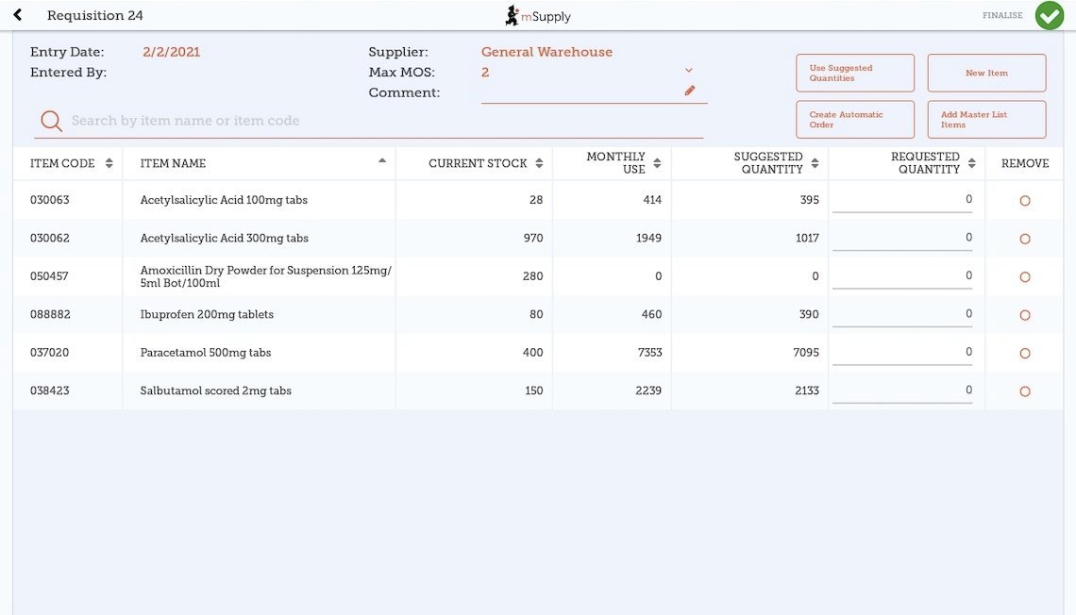
The columns are the same as above for adding New Item.

Use Suggested Quantities
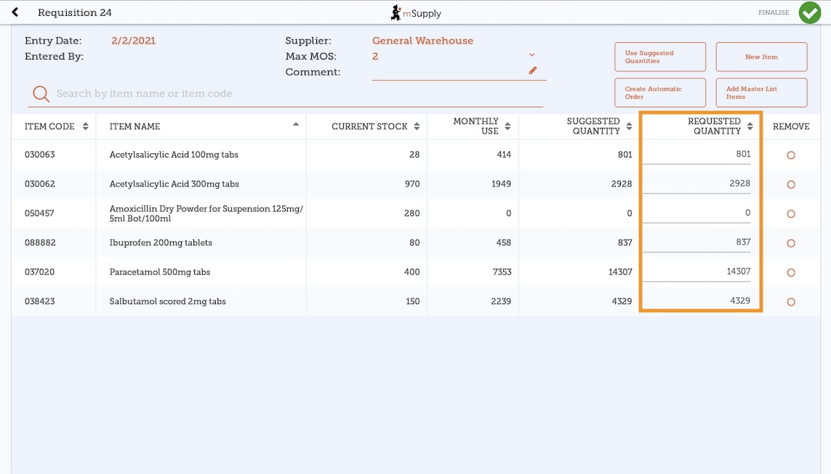
If you tap Use Suggested Quantities on the requisition header, mSupply Mobile will automatically copy the values in the Suggested Quantity column into the Requested Quantity column.
Please note, when you tap Use Suggested Quantities, this will overwrite any value that had previously been entered in the Requested Quantity column. However, you can still check the amount of stock requested for each item and change if required afterward.

Create Automatic Order
If you tap Create Automatic Order on the requisition header, mSupply Mobile will automatically create a supplier requisition with all items stocked at your facility (from all Master Lists) that require stock. That is, any item at your facility that has a suggested quantity greater than zero will be listed. The Requested Quantity column will also be filled with the suggested quantity value.
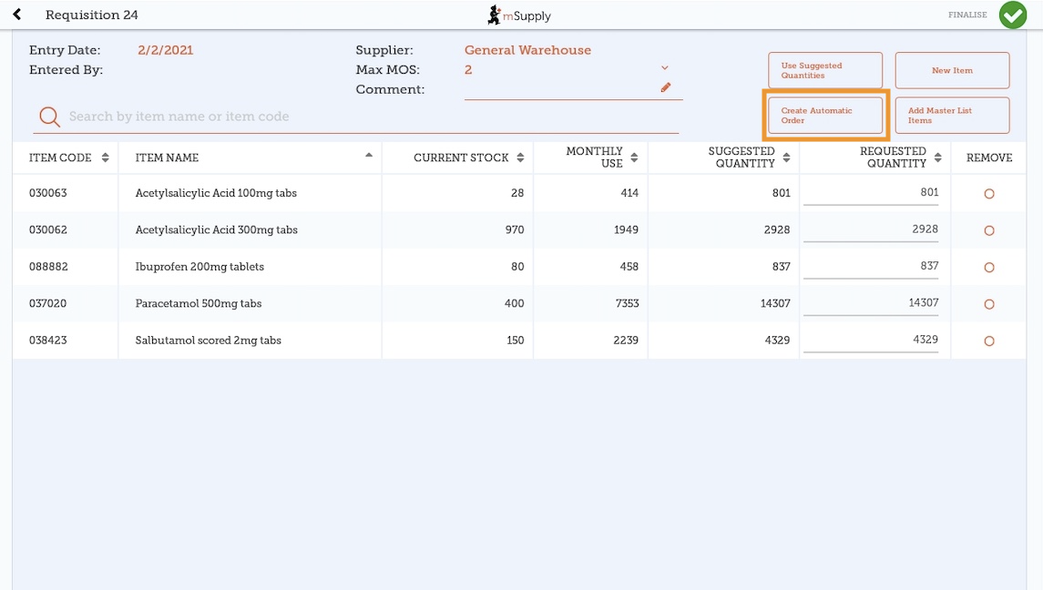
Once again, you can still check the amount of stock requested for each item and change if required.

Finalising a Supplier Requisition

Tap the Finalise button, then Confirm and your order will go to the supply store.
Even if you don't have internet at the time, it's ok! The order will send automatically once your device is able to connect to the internet.
Remember:
A Supplier Requisition is an order that you have placed with your supplier.
A Supplier Invoice is a record of what your supplier has actually sent you.
These are not always the same, as your supplier might not have enough stock to fill your requisition, or they might have sent you some extra stock. When stock arrives at your facility, you should check it off against the Supplier Invoice.
This chapter tells you how to receive stock.

Previous: Customer Requisitions | | Next: Supplier Requisitions (Program Orders)

