mSupply Mobile User Guide menu

Supplier Invoices
After you've sent a Supplier Requisition, (General Order or Program order) to your supply store, that information will be sent to the supplying store for processing. The supplying store processes your requisition into a Customer Invoices for your store. As these customer invoices are created, you will see a corresponding Supplier Invoice in your store. This is exactly like the hard-copy (paper) invoice you would usually receive with your order. You may still continue to receive a paper invoice when your order arrives, but this electronic version in mSupply is the one that you will need to work with.
Let's go through each step…
Only supplier invoices from mSupply stores in your system will appear automatically. If you are receiving stock from a supplier that is not an mSupply store, then a Supplier Invoice will not automatically appear. You will need to create it - see below.

Click on Supplier Invoices
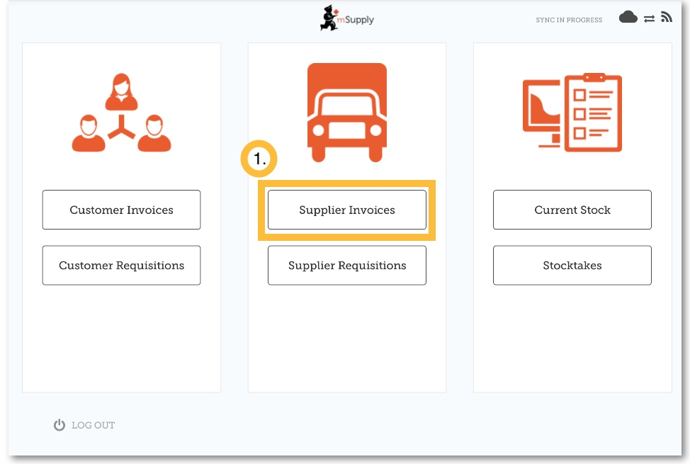
A list of Supplier Invoices will appear.
You can use the Status column to check which orders you have processed or not.
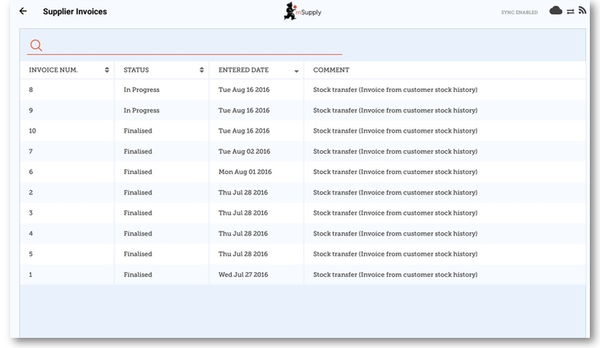

Tap on the Supplier Invoice for the order you have been sent
This will open the Supplier Invoice.

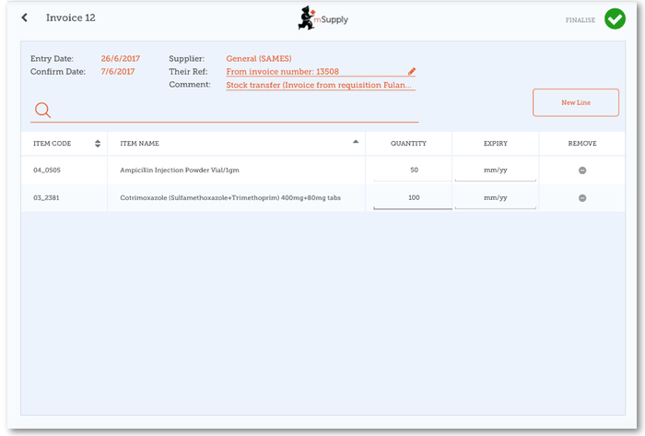
Check each line on the supplier invoice in mSupply Mobile against what you have actually received. If you have received a different quantity to what is displayed, tap on the quantity and adjust it.
The Supplier Invoice should match the stock you are receiving, but it may not. Just as with paper invoices, it is very important that you check everything against the electronic invoice on mSupply Mobile when you order arrives.
When you are satisfied that the Supplier Invoice matches the stock you have received, tap Finalise and then Confirm. This will accept it into your stock. Your Stock On Hand numbers will automatically update!
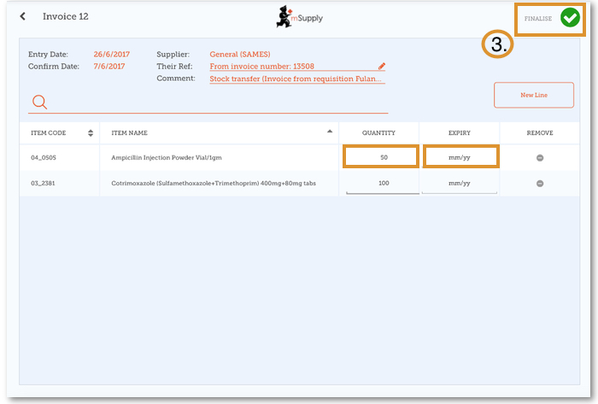

Previous: Supplier Requisitions (Program Orders) | | Next: Supplier Invoices - Returning Stock

