mSupply Mobile User Guide menu

7. Current Stock
One of the most important - but easiest - tasks in mSupply Mobile is to check how much stock you have on hand. When you create a Customer Invoice and add an item, mSupply Mobile will tell you if you have enough stock. But at many other times, you might want to quickly check, and it is very simple to do so.

7.1. Click on Current Stock
This will show a list of the Stock on Hand (quantity) of each item you currently have in stock.
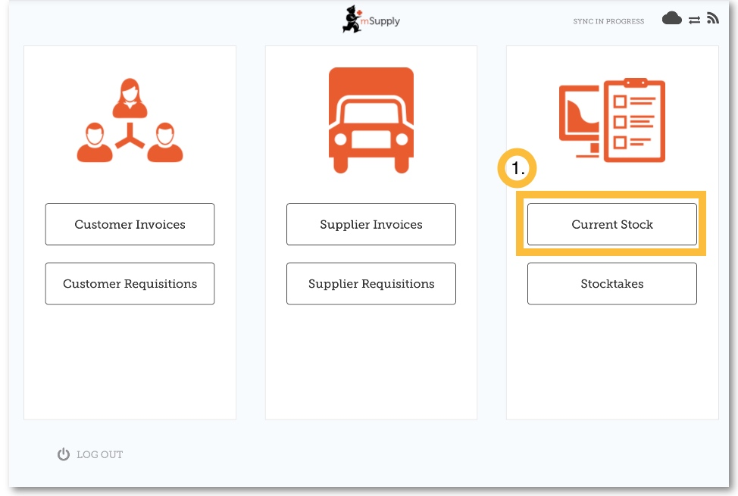

7.2. Click on an item to see more details
You can see more detailed information for a specific item such as the Category, Department, and Earliest Expiry.
You can scroll through the list or search for a specific item by typing the first few letters into the search bar.
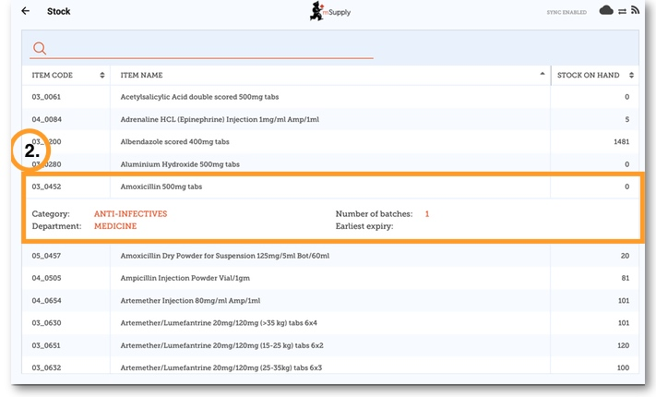

Previous: 6. Supplier Invoices | | Next: 8. Stocktakes (General)

