1. Where to start

Requirements
- A server running mSupply with a web server license registered
- Sync server has a static IP and any network permissions required configured
- A mobile tablet fitting the recommended specifications here

Creating mobile stores for new sites
EACH individual mobile store needs to have the following steps done on the server, which are detailed later in this Server setup guide:
- Create the sync site section 2 of this guide
- Create the mobile store section 3 of this guide
- Configure the mobile store section 4 of this guide
- Create user(s) to access the store section 5 of this guide

Creating mobile stores from existing "Customers" in mSupply
If the stores being created from existing customers in an existing mSupply system, then an additional step needs to be carried out
Merge the existing customer name with the new store. There is some footrunner code that can facilitate this for multiple sites - see 2. Create store from existing customer name using store_create_from_name, below.
However, Any unfinalised CIs from supplying stores to these existing customers need to be finalised first. On a system with supplying stores on multiple sync sites, this can take a long time. Start early, and if possible, ask the supplying stores to refrain from creating new CIs until the merging is done…
If you try to do the merge before finalising unfinalised customer invoices, you will get an error message, and as that message indicates, the merge will not proceed:
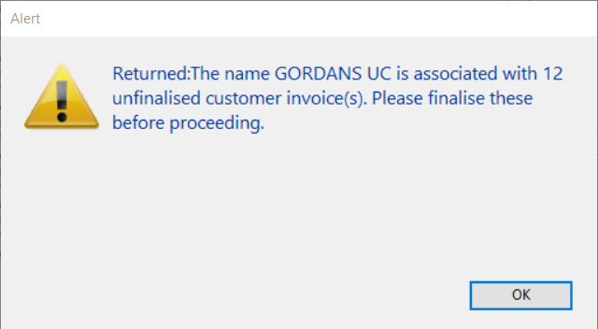

Previous: Setting up the server | | Next: 2

