mSupply Grafana web dashboard
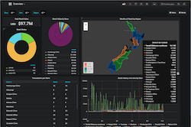
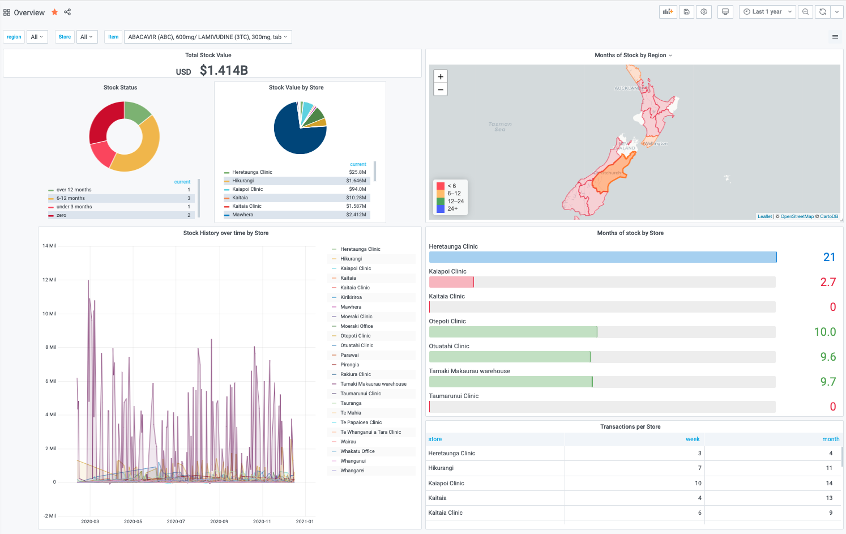
Getting Started
Panels
Time range controls
Sharing
Excel report e-mail scheduler
Organisation Specific Guides
Plugins

