Panels
There are several different Panel types or visualizations you can have on your dashboard.
For instructions on how to configure each type of Panel click here:
- Grafana Graphs
- Grafa Singlestats
- Grafana Tables
- Grafana Dash Lists
- Grafana Text
- mSupply Region Map
- mSupply Table
- mSupply World Map
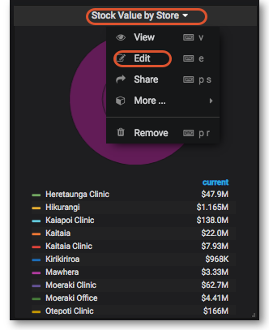
Clicking the title for a panel exposes a menu. The Edit option opens additional configuration options for the panel.
Previous: Getting Started | | Next: Time range controls

