Dashboard
These queries generally need to be set up by an administrator but have been included here as a reference to demonstrate some of the mSupply cold chain data that can be made available on the mSupply Dashboard.

Sensor Graph
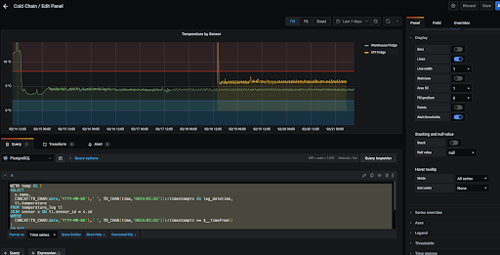

Unacknowledged Breaches
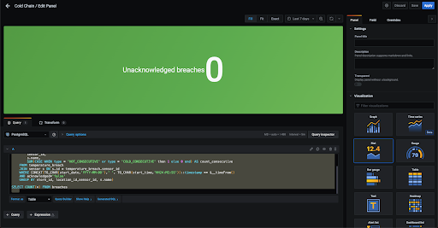

Batches affected
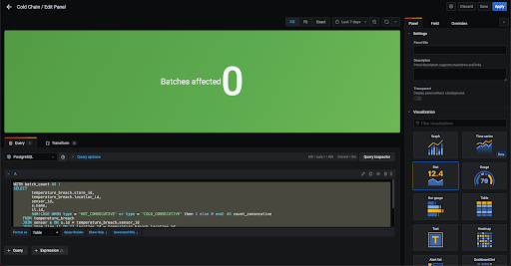

Sensor battery life


